Attachment E:
JDA Customer Solutions Group

Powering Customer Success

JDA Consultants can bring you the knowledge and the power of JDA Software. From assessing your technical architecture and applying business “best practices” to driving business innovation, JDA can work with your staff to execute a well-organized, in-scope, and efficient implementation.
Focusing on your success, your JDA team will provide high-quality services and build a relationship for continued support.

Our Consultants: In the US and Around the Globe
JDA is the global leader for providing integrated software and professional services to retailers and their suppliers. We staff over 340 consultants, trainers and support specialists in the United States and over 640 worldwide.
Our consultants are JDA experienced and have retail, wholesale, and manufacturing industry know-how. JDA has a proven track record of attracting and retaining experienced consultants and locating them close to key markets and clients. You will have worldwide access to expert teams that can lead and support your new solution set. We will provide resumes of all proposed JDA project team members for your review and approval.

Client Focused
We build relationships with our customers and measure ourselves on client satisfaction. Our partnership begins with the planning and design phases of your implementation and continues to grow long after your first success.

Industry and IT Veterans
Your JDA project team’s experience will bring a strong foundation to your implementation. Our consulting team is a commanding blend of industry and IT professionals. As former Buyers, Planners, Distributors, Inventory Mangers, Financial Specialists, Category Captains and CIO’s, JDA Consultants bring experience and insight.
- JDA Consultants have the deepest knowledge of JDA Software and they are certified in both our products and in our methodology. This knowledge and JDA’s commitment to continued education in the latest software, industry advances and technology, assures the seamless integration of your new system into your organization.
- JDA Consultants average 5 years experience with JDA and 10 years industry experience giving JDA the largest breadth of Implementation, Technical, and Industry expertise. JDA is confident that our industry knowledge, business innovation, systems and services capabilities can meet your current and future needs.
- JDA’s Consulting Services Group, established in 1985, brings the credibility that comes with hundreds of implementations all over the world.
- JDA’s senior management team offers leadership to its customers and its consultants. Each client and project is provided an Executive Sponsor to oversee the engagement and work with you to receive the value you expect.

JDA’s Implementation Methodology:
The Optimum Pathway
Our project methodology and practice is constructed to enable us to tailor the implementation around your priorities, timeframes and resources. Our methodology is applicable to a full enterprise solution or a single product implementation. While our methodology is a powerful tool, the key to its success in several hundred client environments is its flexibility. Our methodology can be modified to encompass uniqueness in your business, your organization and/or your technical architecture. JDA project managers can help you prioritize your most pressing requirements, implementing those software applications first, and then integrating other system components as needed or as your budget allows.

Our Methodology is founded on the following concepts:
- Business Processed Oriented
- Benefits Based, Business Focused and Well Defined
- Continually Evolving
- Flexible!
- Built on Common Sense

The diagram below illustrates our methodology:

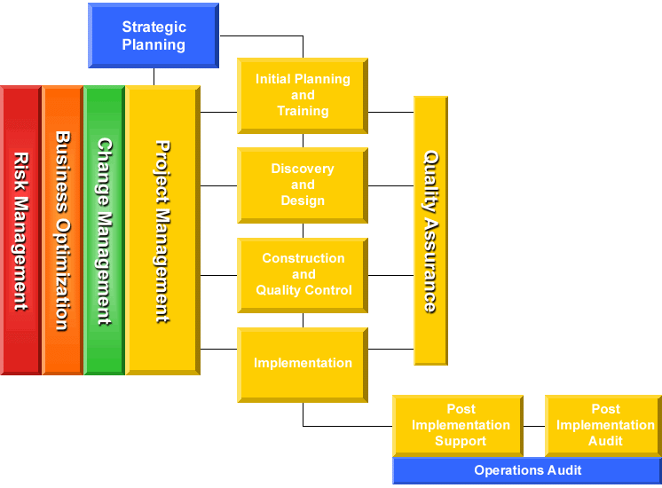

Strategic Planning
JDA Consulting Services Group conducts Strategic Planning meetings to help you plan your business and IT initiatives. This forum also provides JDA with a better understanding of your overall business and goals. In this planning session, you will share your business vision for the next 1-3 years by presenting your high-level strategies and timelines. Our senior management will respond with JDA’s future product direction, integration and product portfolio. Product overviews may be requested to clarify an interest and we can coordinate discussions with specific JDA individuals as needed. Once the visions are clear, we will facilitate a working session to hear your issues, priorities and begin the actual planning. We will have the appropriate people on hand from Consulting Services, Business Development, Sales, Product Management and Product Development to offer input and insight. As a team we will spend our time discussing and resolving any issues, validating assumptions, assigning priorities, and working toward the deliverable of a one to three year IT plan.

Initial Planning & Training
During the Project Planning and Kick Off meeting we introduce key project team members discuss and ratify project assumptions, project scope, strategy, critical project dates and the overall project approach. We will work toward agreement on staffing requirements, review communication and reporting requirements, administration, budget, and schedule the Business Process Analysis workshops. At the conclusion of this meeting JDA will prepare a detailed project plan and scope document. Subsequent to the Business Process Analysis phase, we can assist your organization with the initial load of the application and conduct software configuration and hardware orientation with your project team. JDA also strongly advises that your management team attend the product overview courses offered by JDA University. By developing a plan and attending the overview course, your team will be better prepared to participate in the integration of the business process and supporting system functionality discussed in Discovery and Design phase.

Discovery and Design
This phase focuses around Business Process Analysis (BPA) which is a series of collaborative tasks between you and JDA. The purpose of the BPA phase is to help align business activities and systems for optimal performance. Key personnel are interviewed to understand the business workflow. The interviews lead to team workshops that review current processes for strengths and inefficiencies, identify business performance improvement opportunities and determine your optimal system usage and configuration. To create your future vision, JDA has developed baseline process models. The models combine “best practice” business processes with the functionality of JDA’s supporting technology. Through this cooperative effort the team will define processes for both business activities and optimal systems support.

Construction & Quality Control
JDA can lead your team in configuring your system based on the decisions made in the BPA. Configuration services include option settings, customizing the user interface, application parameter set-up, recommendations for establishing organizational structures, and configuring the system data interchange module. JDA can also provide assistance with the development of test scripts and the test plan. During this phase the JDA project team works to ensure that the software, hardware and operating procedures are in place before training end users. JDA can provide on-site support to validate that all operating procedures are in place, system data is correct, interfaces to other systems are exchanging information correctly and software enhancements are functioning according to specification.

Implementation
During this phase of the project JDA can provide planning for end-user training, assist with a cut-over migration plan, a pre-implementation review, and assist with the conversion of production data and validation. JDA can also provide on-site go live and post implementation support, and a post system review.

Post Implementation Support & Audit
Post Implementation Support and Audit ensures that the client environment is running smoothly and to your satisfaction prior to the transition to JDA’s Client Support Services. A post implementation audit can be done to review all pertinent project documentation, log any outstanding issues and plan a path to resolution.

Project Management
Your JDA Project Manager will provide leadership in all phases of your project. The JDA Project Manger will be responsible for project planning, status reporting, issues resolution, resource coordination, budget review and maintenance. Your Project Manager will pro-actively work to keep the project on track, and will be available on a day-to-day basis to facilitate each aspect of the project. In addition your Project Manager will ensure a plan is followed throughout the project to provide your organization with the skills and knowledge to be completely independent of JDA once the project is complete.

Change Management
With this service, JDA process consultants can drive the changes identified in Business Process Analysis sessions, develop communication plans and incorporate business process decisions into testing and training. The lead change manager facilitates the implementation of new processes within the organization throughout all phases of your implementation.

Business Process Optimization
This engagement is an extension of the Business Process Analysis and Design phase in which JDA process consultants can assist in the alignment of your organization to support the new business processes and system procedures. With this engagement JDA can provide job descriptions, develop performance models, constantly measure implementation results, and conduct periodic performance evaluations.

Risk Management
Risk Management is a service in which JDA’s risk management consultants can facilitate risk assessments and ensure the proper action plans are defined, and followed up on after each project milestone. This service can ensure that changes to the project team, business environment and other internal or external factors are recognized and addressed with a timely action plan.

JDA Partnership Programs
- JDA’s Annual User Group Conference: FOCUS
- Frequent Customer Tele-briefings Featuring New Products and Services
- Quick Hit Improvement Programs
- Alliances and Third Party Partnerships
- Premier Partner Program

Why JDA’s Projects Succeed
Successful Business Model Credibility
Proven Methodology Confidence
Commitment to Education Knowledge
Excellent Recruiting and Retention Growth & Consistency
Executive Sponsorship Leadership

JDA Solutions: The Complete Solution
JDA is with you every step of the way to support your business as it changes and grows. Our services are geared to meet all of your needs. We understand that our success is based on your success so we don’t stop at the installation of your software but we strive to become your long-term strategic business partner.
Below is a sampling of the breadth of the services we can provide:

Implementation Solutions Business Consulting Solutions
“JDA’s Core Solutions for Success” “JDA’s Strategic Solutions for
Optimization of Your Business”
Project Planning & Management Strategic Planning
Business Process Analysis Business Process Optimization
Configuration & Installation Change Management
Quality Assurance & Integration Testing Risk Management
Application Integration Support Business Intelligence
Post Implementation Audit & Support Vendor Collaboration

Technical Solutions Customer Support
“JDA’s Infrastructure Planning and “JDA’s Global Support for Your
Technical Support Solutions” Business and Your Self Sufficiency”
Modification Development Passport Support
Interface Development Custom Passport Support
Data Conversion Premier Passport Support
Database Administration Annual 24 X 7 Coverage
Technical Architecture Analysis Extended Hours
Technical Benchmarking

Business Operation Solutions Education
“JDA’s Solutions for Outsourcing, “JDA’s Education Solutions
Collaboration, Planning, Forecasting Supporting Your Business Vision”
and CPFR”
Application Service Provider Functional & Technical Training
Information Technology Management Customized Curriculums
Category Management Customized Procedure Manuals
Space Management Computer Based Training

